Johnson Recreation Committee Thursday, June 18, 2020
6 p.m. – 7 p.m.
Please join us by following this link or going to https://zoom.us/ and joining Meeting ID: 344 652 2544. You can also join by phone by calling:
+1 646 558 8656 US (New York)
+1 253 215 8782 US
+1 301 715 8592 US
and using Meeting ID: 344 652 2544

Agenda: 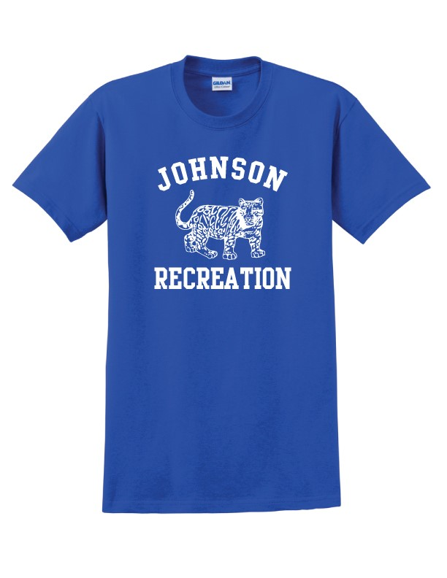
- Elect officers –

- Update on Rec. Coordinator hours –

12 hours July and August
- Rec. t-shirt logo – vote on logo

- Soccer Registration – link built – discuss details

Coaches:
Tournament:
Refunds:
COVID-19 Tracking:
Uniform handout:

- Budget review – monthly update – June EOY – we are on track – budget for next year is in approved and we will monitor based on registrations.

- LVRT Signage – Rise VT Grant – Kim Dunkley – Great Big Graphics

- Summer Rec. Open house day – Review -ACCD link for planning – Jenn Yuris and I will be meeting, when she finishes school, to plan.
- JES Facility requests – 1 per sport – meet with Kelly Hickey and plan the calendar for the year.

Rec. news from the select board –
- Healthy Lamoille Valley initiative to make OMP smoke free passed
- New Background check passed – we will use the same for as JES or people can fill out a form with us saying that JES can share their background check with us.
- Greg Davis has agreed to do a basketball coach clinic for us in November.
- New request form and price list for OMP Field Rentals
- Working Dog delivering portalet to Legion Field
- Conservation Committee - taking apart the backstop at chuckaberry field to use as a compost fence as they repurpose that field into an arboretum.

Meeting site: Zoom (see above)

